I have split this post into 2 roadways :

* Embedded IoT Developer 🧑‍💻
* IoT Application Developer 🧑‍💻

The Way road maps are structured as follows:

* Programming Languages
* Concepts
* Tools

## **Embedded IoT Developer**

### **Programming Languages 💻:**

* Embedded C (Must Have)
* C++ (Must Have)
* Python (Must Have)
* Bash Scripting (Nice To have)
* Rust (Nice To have)

Those Programming Languages are going to give you a head start to kickstart the embedded journey where C++ and Embedded C are the bare minimum to get started

#### **Concepts 🧠:**

* RTOS (Must Have)
* IoT Value Chain (Must Have)
* IoT Security (Nice To Have)
* Wireless Communication (Must Have)
* OS Fundamentals (Must Have)
* Cloud Computing Basics (Nice To Have)
* Linux (Must Have)
* Web Services (Nice To Have)
* Pub / Sub Systems (Must Have)
* Embedded Design Patterns (Must Have)
* Networks (Nice To Have)

These Concepts are mandatory to be able to work comfortably developing IoT Solutions.

### **Tools 🧰:**

* Platform IO
* CMake
* Esp IDF

### **Target Architectures**

* RISC
* CISC

The difference between CISC and RISC Targets should be understandable during the development of Embedded IoT Solutions

You Can Try the Following Targets / Dev Boards:

#### **Targets**

* STM32 (Blue/Black Pill)
* Esp32 / NodeMCU
* Raspberry Pi (Embedded Linux)
* BeagleBone (Embedded Linux)
* Jetson Nano (Embedded Linux)

To Work with those Targets and get something useful out of them you have to understand the target peripherals which include the following:

#### **Microcontroller Peripherals 🎮**

* GPIO
* Timers
* PWM
* ADC
* DAC
* Serial Communication(SPI,I2C,UART)
* Wifi
* Memory(Flash,SRAM,EEPROM)
* BLE

### **Here is a High-Level Mindmap 🗺️:**

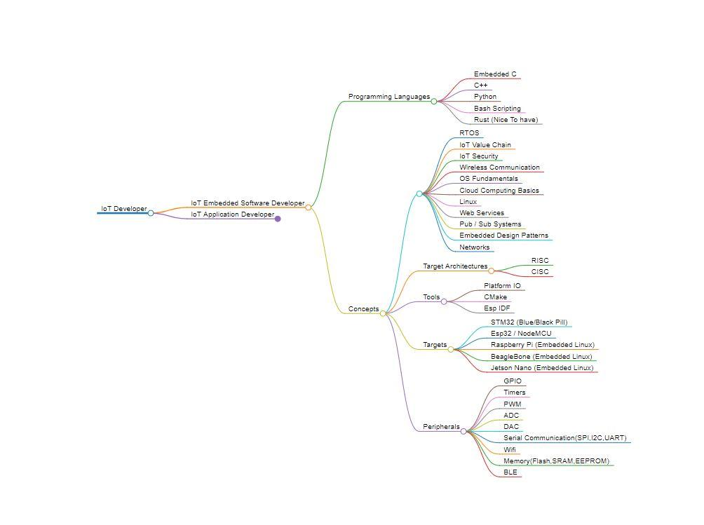

## **IoT Application Developer**

For you to become an IoT application developer you have to wear a lot of hats and be knowledgeable in a lot of things, you should not think that you have to expert at all of these but at least have some idea of how to work with the following:

* Frontend
* Backend
* Cross-Platform Mobile Development (Nice to Have)

you can choose from the below frameworks whatever you feel comfortable working with or have worked with before.

### 

### **Programming Languages 💻:**

* TypeScript
* JavaScript
* Python
* Java

### **Frameworks**

#### **Frontend**

* React
* Angular
* Vue
* Svelte

#### **Backend**

* ExpressJS
* NestJS
* FastAPI
* Flask
* Django
* SpringBoot
* GO

#### **Mobile Technologies**

* Flutter
* React Native

### **Concepts 🧠**

* IoT Value Chain
* IoT Security
* Wireless Communication
* OS Fundamentals
* Cloud Computing Basics
* Linux
* Web Services
* Pub / Sub Systems
* System Integration
* Networks
* M2M
* Design Patterns

For Realtime operating systems you just have to understand how they work and how to deal with event loops because you can work with one.

### **RTOS**

* Mynewt
* FreeRTOS
* Amazon FreeRTOS
* NuttX

For Internet Protocols they are mandatory that you understand how they work with different Architectures, for example, client/server or pub/sub systems

### **Internet Protocols**

* HTTP/HTTPS
* MQTT
* COAP
* AMQP

### **Wireless Technologies**

* LORA
* BLE
* WIFI
* NFC Industrial protocols are not mandatory but they are nice to have and to understand how they work if you want to work in the IIOT space then they will become very important and give you a headstart.

### 

### **Industrial Protocols**

* OPC UA
* Modbus

### **Distributed Computing**

You should at least know one of the following message brokers to implement distributed computing and asynchronous code execution

* Microservices

##### **Message Brokers**

* Kafka
* RabbitMQ
* HiveMQ
* EMQX
* ESB eg. WSO2

You have to know at least one Relational database, one NoSQL database, and one Timeseries database as well as keystore databases.

### **Databases**

* Mysql
* Postgresql
* MongoDB
* Cassandra
* Redis Cache
* InfluxDB

Time to market is really important to Enterprise companies that's why they use Application Enablement Platforms, where they can develop IoT solutions faster below are the most popular ones in the market varying from open source to fully paid solutions

### 

### 

### **IoT Platforms(AEP)**

* ThingsBoard
* The Things Industries
* Mainflux
* ThingsWorx
* Losant
* ThingsWorks
* Cumulocity
* Data Cake

### **Cloud Native Technologies & Tools 🧰**

* Kubernetes
* Docker
* Prometheus

#### **Monitoring 🖥️**

Monitoring your assets applications and servers is key to successful IoT deployment and maintenance Grafana is one of the best monitoring and visualization tools

* Grafana

### **IoT CLoud Providers**

There are two types of AEPs One we call an *Application enablement platform* and one we call a *Hyperscalers*, Amazon, and Microsoft are considered as Market Hyperscalers that enter the cloud and IoT space to provide premade services to accelerate your time to market and development cycle

* AWS IoT
* Azure IoT

### **Here is a High-Level Mindmap 🗺️:**

